Oracle Homework SQL Chapter 7: Joins
You may only use any information that is given to you in the problem.
Include the following comments at the top:
-- Your Name
-- Date
Put all of the queries in one script, and do not zip the file.

1. Create a listing of all employee’s jobs, i.e. those job_ids in the Employees table, their location ID and their locations (state/Province). Order by job. Do not repeat any rows. The results of the query are shown below:

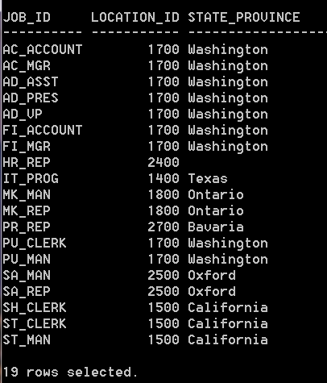

2. Write a query to display the employee name, job title and dept name of all IT employees. Order by employee name. Label columns as shown:

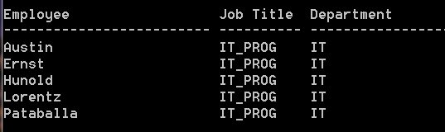

3. Display the grade level, department name, and salary for all employees whose department name starts with “S”. Do not show duplicate rows. Order by the grade level, and then department name, then by salary descending. (48 rows returned)

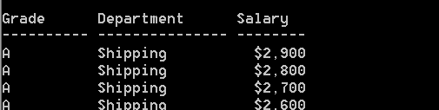
Etc…

4. (Self Join) Create a query that will display the name of all employees that work in the same department as the person who is President (AD_PRES). Name the column “Upper Management”. Order by person’s name. You cannot use the President’s name (King) in the SQL code. For the job title, spell out the full title, that is, Vice President for VP and President for Pres.

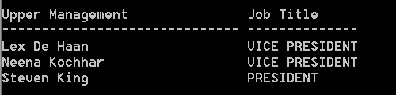

5. Display the city and country of all locations in the locations table. Include those countries even if they do not have a matching city.

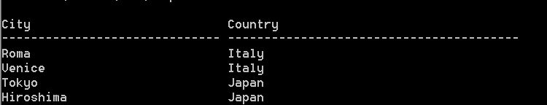
ETC>>>>>>>>>>>
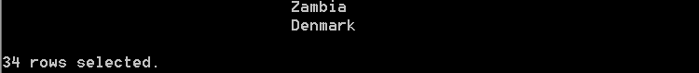

6. Display the instructor’s last name, the section number (from course section table), the location id number, and building for all courses taught in the Business building. Order by the faculty’s last name, then the section number. Format and label the columns as shown:

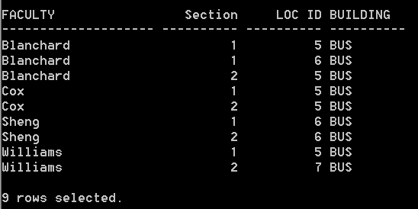

7. The HR department needs to find the names and hire dates of all the employees who were hired before their managers, along with their managers’ names and hire dates. Only include those rows where both the employee and the manager were hired during the year 2000.

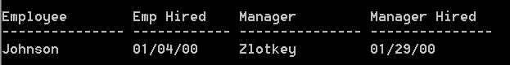
- Using the Animal Shelter schema, create a new problem using the features from this chapter.

